LAB EXERCISE
Name: Y.Devi priya
Reg.no: 192465042
Exp1:
library(DiagrammeR)
library(dygraphs)
library(xts)
grViz("
digraph G {
rankdir=LR
Git -> GitHub -> RStudio -> DevSecOps_Tools
}
")
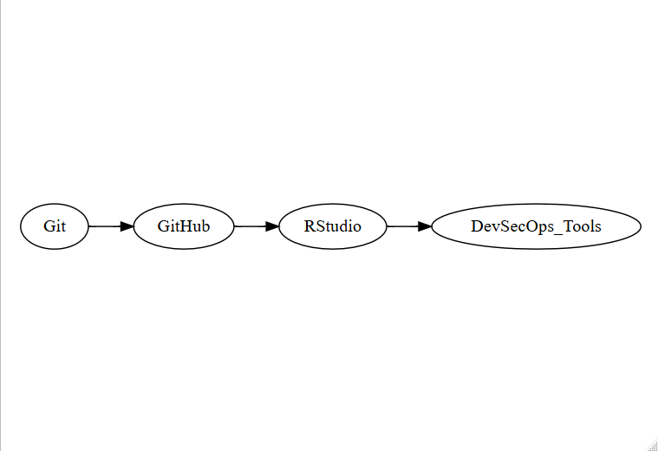
Exp2:
library(DiagrammeR)
library(dygraphs)
library(xts)
grViz("
digraph G {
rankdir=LR
Plan -> Code -> Build -> Test -> Deploy -> Monitor -> Plan
}
")
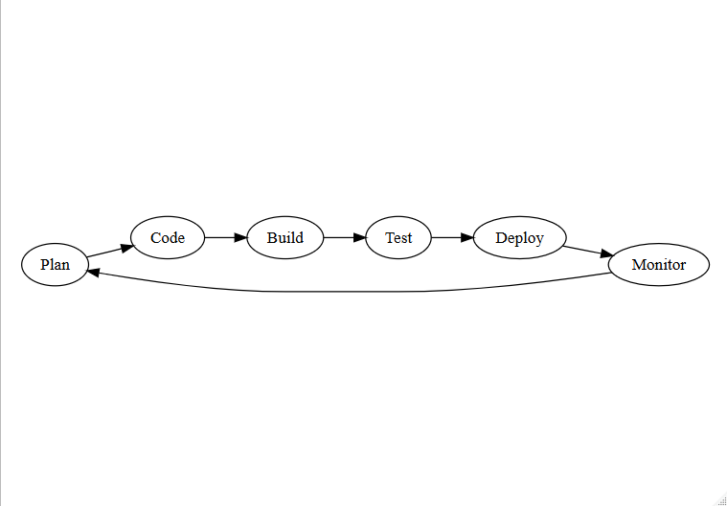
Exp 3:
library(DiagrammeR)
library(dygraphs)
library(xts)
d <- 1:10
x <- xts(cbind(
DevOps = c(60,62,65,63,68,70,72,71,75,76),
DevSecOps = c(65,67,70,72,74,76,79,82,84,87)
), order.by=as.Date("2026-07-01")+d-1)
dygraph(x, main="DevOps vs DevSecOps")
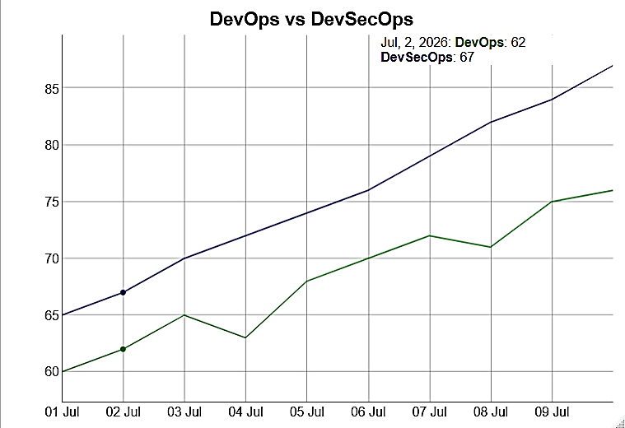

Exp4:
library(DiagrammeR)
library(dygraphs)
library(xts)
x <- xts(cbind(
Risk = c(20,35,45,30,55,40,25,60,50,30)
), order.by=as.Date("2026-07-01")+0:9)
dygraph(x, main="Security Risk Simulation")
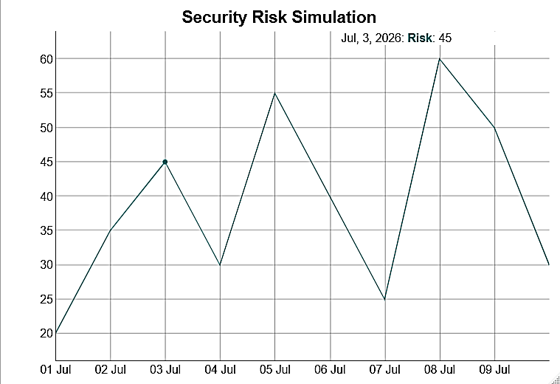
Exp5:
library(DiagrammeR)
library(dygraphs)
library(xts)
x <- xts(cbind(
Threats = c(2,4,6,9,12,10,8,6,4,3),
AttackSurface = c(10,15,20,28,35,32,27,22,18,15)
), order.by=as.Date("2026-07-01")+0:9)
dygraph(x, main="Threat Propagation")
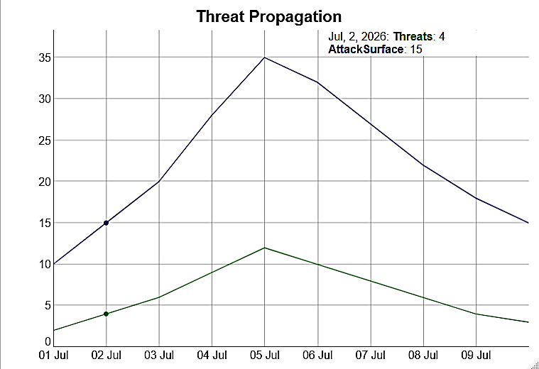
Exp6:
library(DiagrammeR)
library(dygraphs)
library(xts)
grViz("
digraph G {
rankdir=LR
Code -> Security_Check -> Test -> Build -> Deploy
}
")
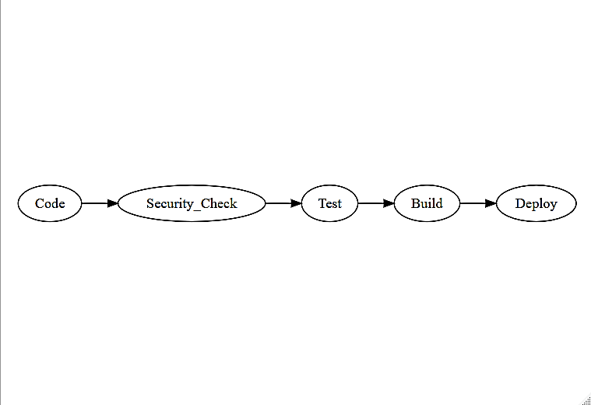
Exp7:
library(DiagrammeR)
library(dygraphs)
library(xts)
x <- xts(cbind(
Vulnerabilities = c(12,10,9,7,6,5,4,3,3,2)
), order.by=as.Date("2026-08-03")+0:9)
dygraph(x, main="SAST Vulnerability Detection")
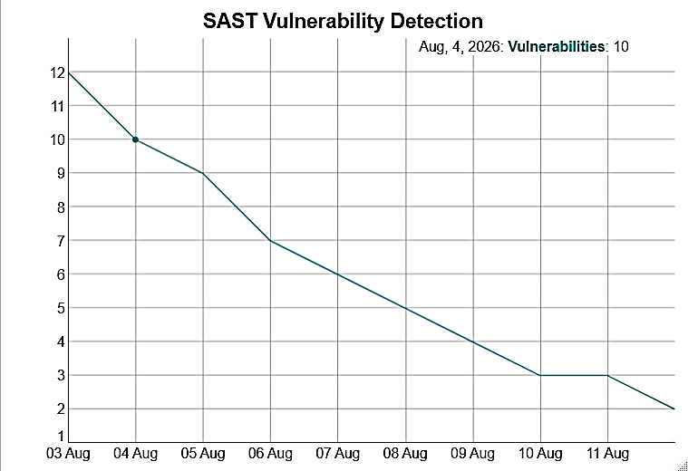
Exp8:
library(DiagrammeR)
library(dygraphs)
library(xts)
x <- xts(cbind(
Vulnerabilities = c(15,13,12,10,9,8,6,5,4,3)
), order.by=as.Date("2026-08-07")+0:9)
dygraph(x, main="DAST Security Scan")
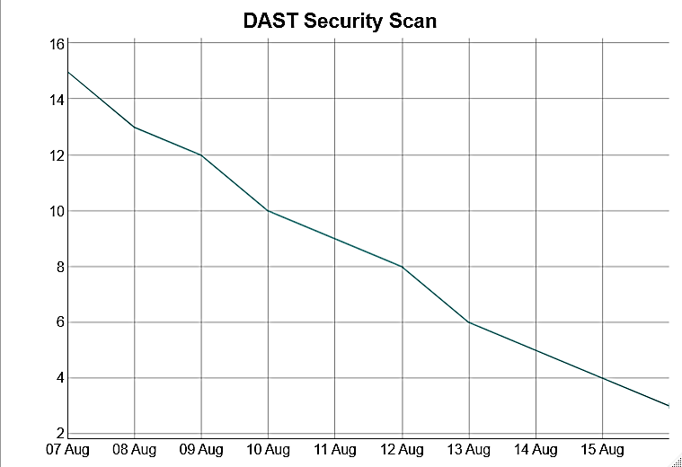
Exp9:
library(DiagrammeR)
library(dygraphs)
library(xts)
x <- xts(cbind(
VulnerableDependencies = c(10,9,8,8,6,5,5,3,2,1)
), order.by=as.Date("2026-08-12")+0:9)
dygraph(x, main="SCA Dependency Vulnerabilities")
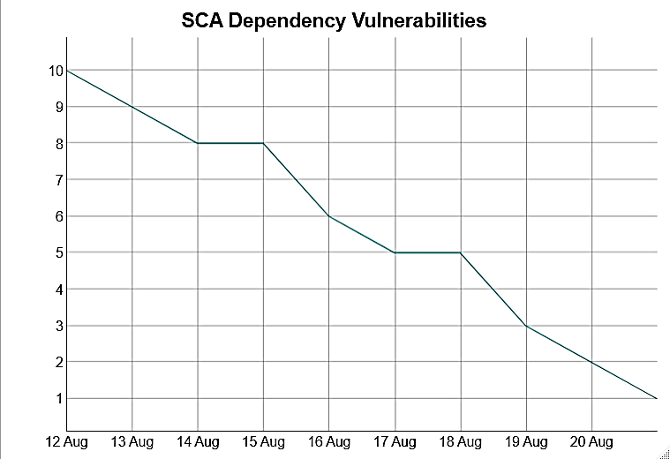
Exp10:
library(DiagrammeR)
library(dygraphs)
library(xts)
x <- xts(cbind(
Critical = c(8,7,6,5,4,3,3,2,1,1),
High = c(12,11,10,9,8,7,6,5,4,3)
), order.by=as.Date("2026-08-17")+0:9)
dygraph(x, main="Vulnerability Trends")
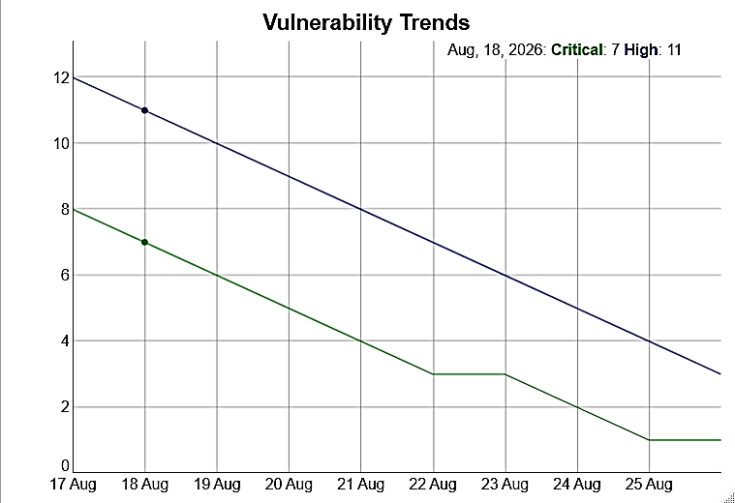
Exp11:
library(DiagrammeR)
library(dygraphs)
library(xts)
grViz("
digraph G {
rankdir=LR
Developer -> Git -> IaC -> Cloud -> Secure_Application
}
")
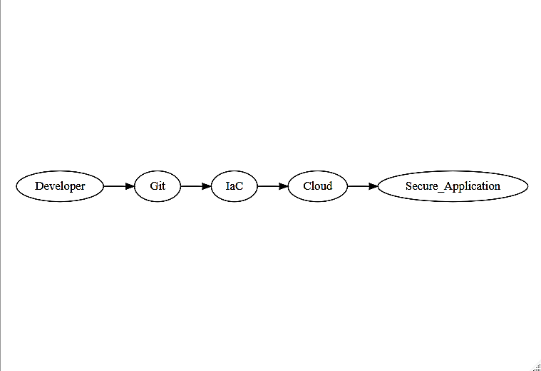

Exp12:
library(DiagrammeR)
library(dygraphs)
library(xts)
grViz("
digraph G {
User -> Role -> Permission -> Resource
}
")
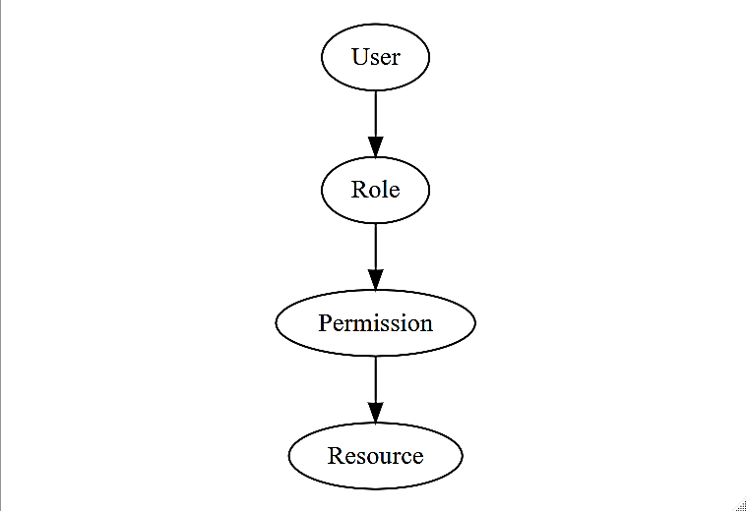
Exp13:
library(DiagrammeR)
library(dygraphs)
library(xts)
grViz("
digraph G {
rankdir=LR
Developer -> Git -> CI -> Security_Check -> CD -> Kubernetes
}
")
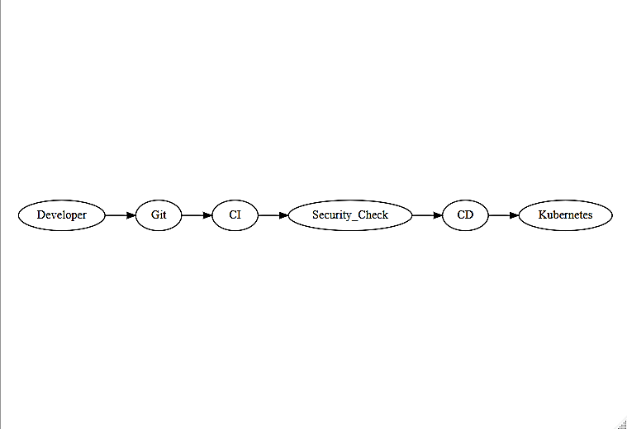
Exp14:
library(DiagrammeR)
library(dygraphs)
library(xts)
x <- xts(cbind(
Vulnerabilities = c(14,13,11,10,8,7,6,4,3,2)
), order.by=as.Date("2026-09-04")+0:9)
dygraph(x, main="Container Vulnerability Assessment")
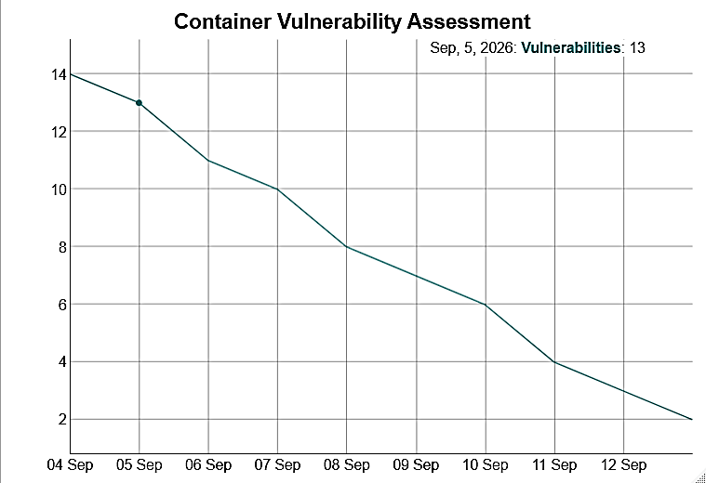
Exp15:
library(DiagrammeR)
library(dygraphs)
library(xts)
x <- xts(cbind(
Events = c(5,6,7,8,20,7,6,5,18,6)
), order.by=as.Date("2026-09-09")+0:9)
dygraph(x, main="Security Events and Anomalies")
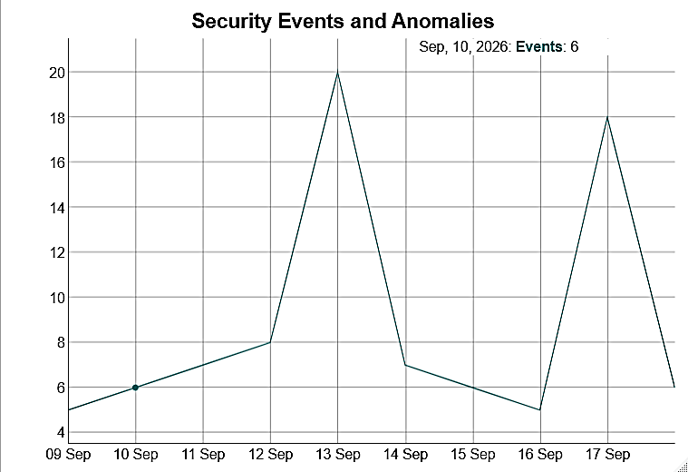
Exp16:
library(DiagrammeR)
library(dygraphs)
library(xts)
x <- xts(cbind(
SecurityScore = c(65,68,70,72,75,74,78,80,83,85),
Vulnerabilities = c(20,18,17,15,13,12,10,8,7,5)
), order.by=as.Date("2026-09-14")+0:9)
dygraph(x, main="DevSecOps Security Dashboard")
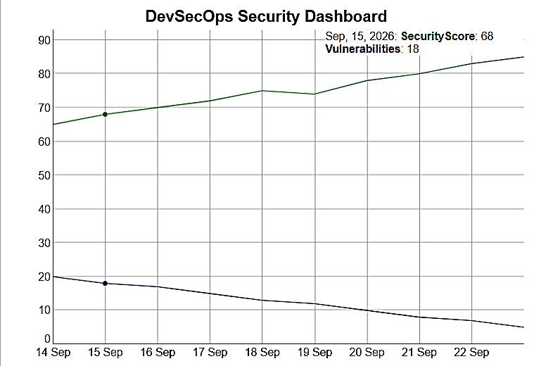
Exp17:
library(DiagrammeR)
library(dygraphs)
library(xts)
x <- xts(cbind(
Vulnerabilities = c(18,16,15,13,11,9,8,6,4,3)
), order.by=as.Date("2026-09-16")+0:9)
dygraph(x, main="Secure Coding Simulation")
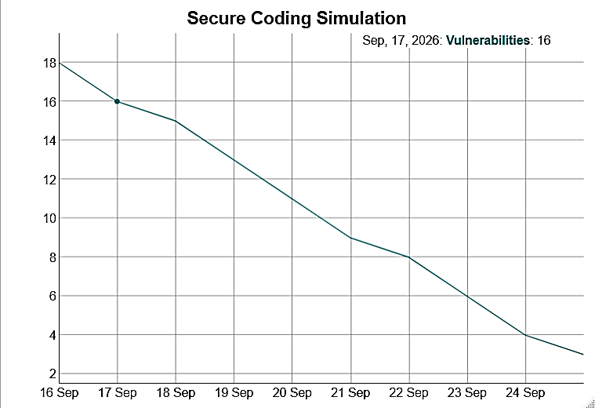
Exp18:
library(DiagrammeR)
library(dygraphs)
library(xts)
grViz("
digraph G {
rankdir=LR
Application -> OWASP_Top_10 -> Risk_Classification
}
")
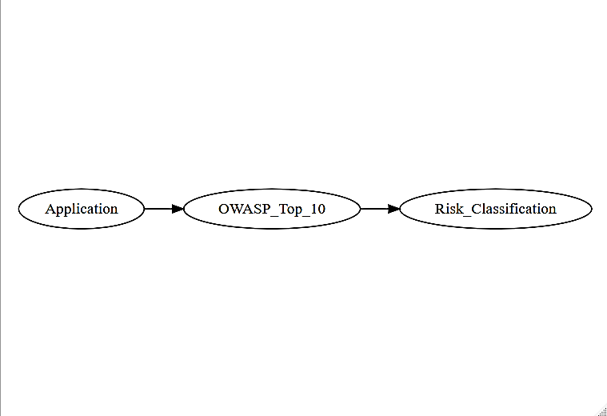
Exp19:
library(DiagrammeR)
library(dygraphs)
library(xts)
x <- xts(cbind(
Passed = c(5,6,7,7,8,9,9,10,10,10),
Failed = c(5,4,3,3,2,1,1,0,0,0)
), order.by=as.Date("2026-09-21")+0:9)
dygraph(x, main="Automated Security Verification")
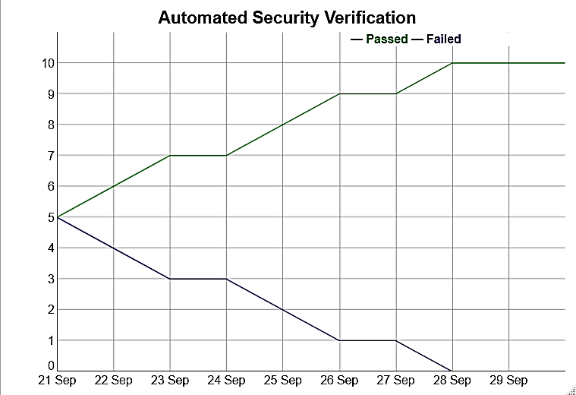
Exp20:
library(DiagrammeR)
library(dygraphs)
library(xts)
x <- xts(cbind(
Passed = c(3,4,5,6,7,7,8,9,9,10),
Failed = c(7,6,5,4,3,3,2,1,1,0)
), order.by=as.Date("2026-09-23")+0:9)
dygraph(x, main="CI/CD Quality Gate")
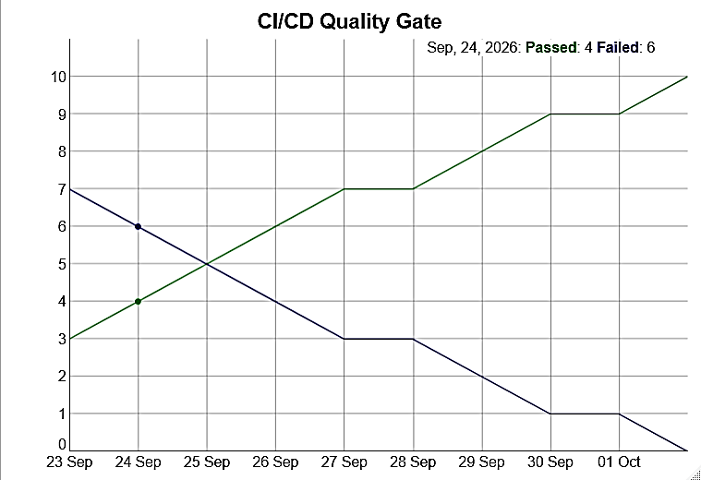
Exp21:
library(DiagrammeR)
library(dygraphs)
library(xts)
x <- xts(cbind(
CVSS = c(3.2,5.1,6.4,7.2,8.1,9.0,6.8,4.5,8.7,7.5)
), order.by=as.Date("2026-09-25")+0:9)
dygraph(x, main="CVSS Vulnerability Scores")
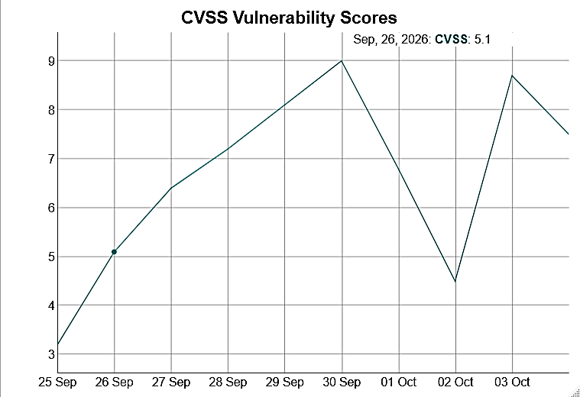
Exp22:
library(DiagrammeR)
library(dygraphs)
library(xts)
x <- xts(cbind(
SecretsFound = c(12,10,9,8,6,5,4,3,2,1)
), order.by=as.Date("2026-09-28")+0:9)
dygraph(x, main="Secrets Detection")
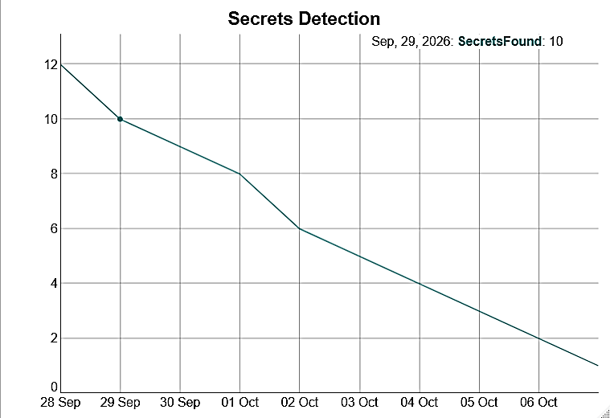
Exp23:
library(DiagrammeR)
library(dygraphs)
library(xts)
x <- xts(cbind(
Vulnerabilities = c(10,9,8,7,6,5,4,3,2,1)
), order.by=as.Date("2026-09-30")+0:9)
dygraph(x, main="API Security Testing")
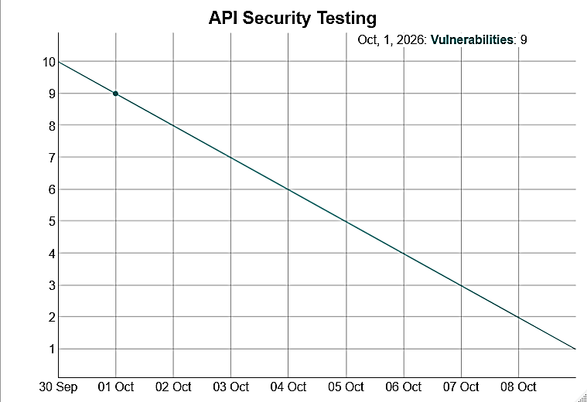
Exp24:
library(DiagrammeR)
library(dygraphs)
library(xts)
x <- xts(cbind(
Vulnerabilities = c(16,15,13,12,10,9,7,6,4,3)
), order.by=as.Date("2026-10-02")+0:9)
dygraph(x, main="Web Application Vulnerabilities")
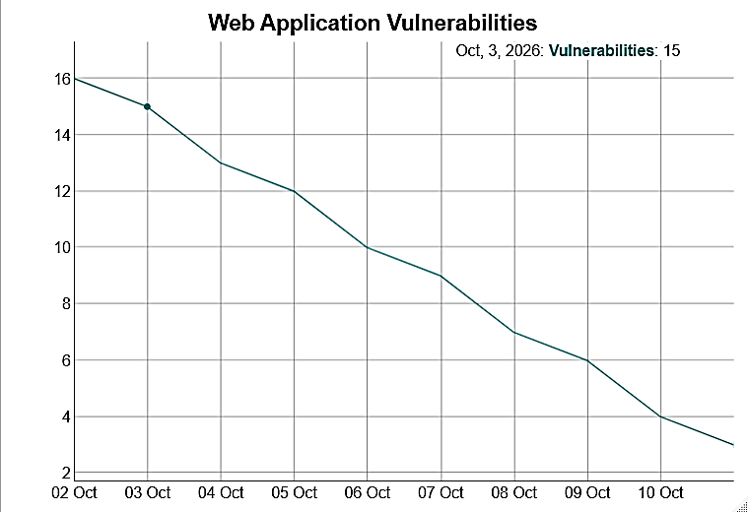
Exp25:
library(DiagrammeR)
library(dygraphs)
library(xts)
x <- xts(cbind(
Allowed = c(8,9,10,11,12,13,14,15,16,17),
Blocked = c(7,6,6,5,4,4,3,2,2,1)
), order.by=as.Date("2026-10-05")+0:9)
dygraph(x, main="Rule-Based Security Policy")
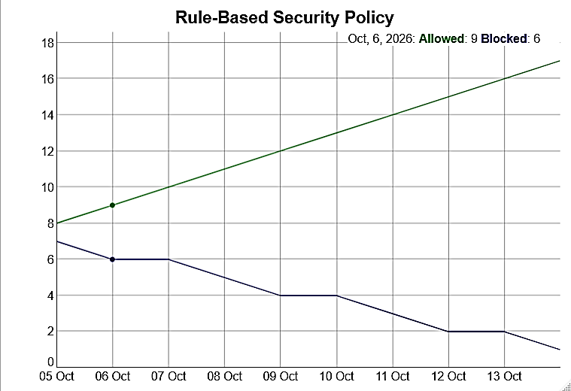
Exp26:
library(DiagrammeR)
library(dygraphs)
library(xts)
grViz("
digraph G {
Start -> Security_Gate
Security_Gate -> Deploy [label='PASS']
Security_Gate -> Reject [label='FAIL']
}
")
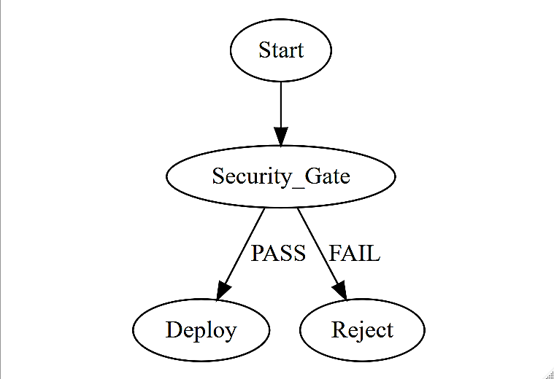
Exp27:
library(DiagrammeR)
library(dygraphs)
library(xts)
x <- xts(cbind(
SecurityKPI = c(60,63,66,68,71,74,76,79,82,85)
), order.by=as.Date("2026-10-09")+0:9)
dygraph(x, main="Security KPI Trend")
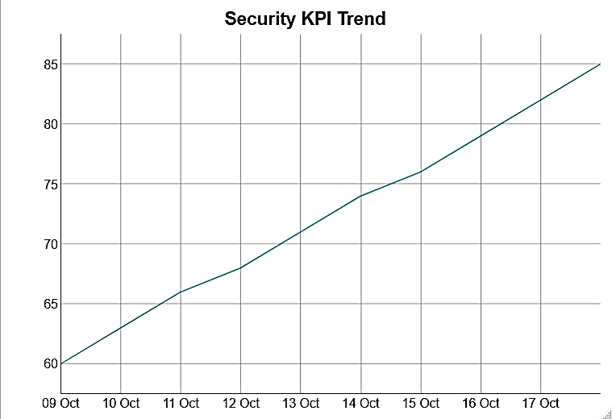
Exp28:
library(DiagrammeR)
library(dygraphs)
library(xts)
x <- xts(cbind(
Detected = c(4,6,5,8,10,7,6,5,3,2)
), order.by=as.Date("2026-10-12")+0:9)
dygraph(x, main="Continuous Security Monitoring")
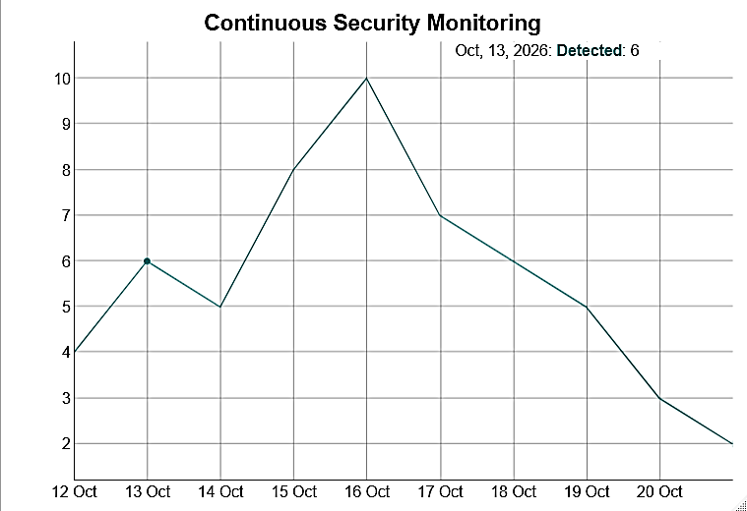
Exp29:
library(DiagrammeR)
library(dygraphs)
library(xts)
x <- xts(cbind(
Events = c(4,5,6,15,7,6,18,8,5,4),
Correlated = c(1,2,2,8,3,3,10,4,2,1)
), order.by=as.Date("2026-10-14")+0:9)
dygraph(x, main="Security Event Correlation")
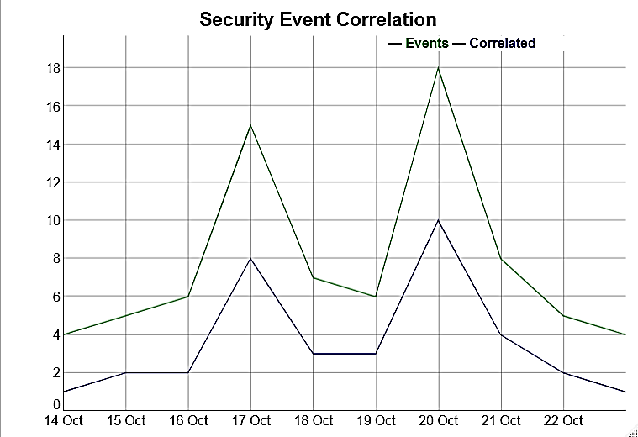
Exp30:
library(DiagrammeR)
library(dygraphs)
library(xts)
x <- xts(cbind(
Normal = c(20,22,21,23,22,21,24,23,22,21),
Anomaly = c(1,2,1,3,10,2,1,8,2,1)
), order.by=as.Date("2026-10-16")+0:9)
dygraph(x, main="Intrusion and Anomaly Detection")
C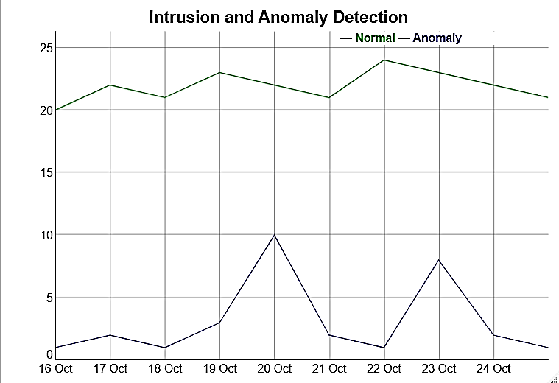
Exp31:
library(DiagrammeR)
library(dygraphs)
library(xts)
x <- xts(cbind(
Low = c(8,9,10,11,12,13,14,15,16,17),
High = c(6,6,5,5,4,4,3,3,2,2),
Critical = c(2,2,3,2,2,1,2,1,1,1)
), order.by=as.Date("2026-10-19")+0:9)
dygraph(x, main="Incident Severity")
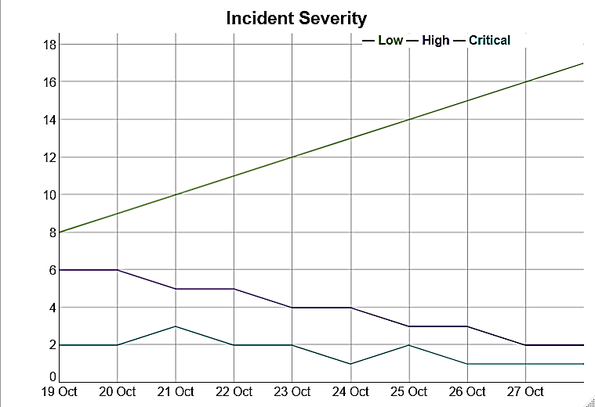
Exp32:
library(DiagrammeR)
library(dygraphs)
library(xts)
grViz("
digraph G {
rankdir=LR
Detect -> Classify -> Contain -> Eradicate -> Recover
}
")
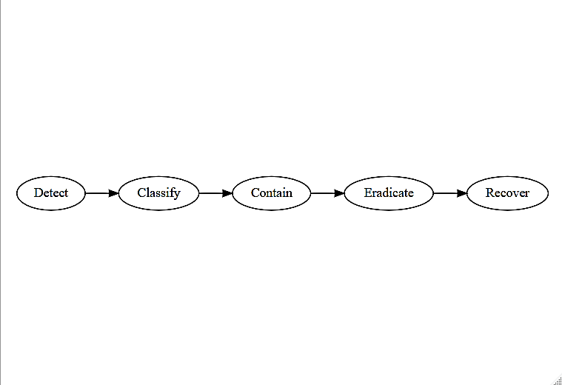

Exp33:
library(DiagrammeR)
library(dygraphs)
library(xts)
x <- xts(cbind(
IncidentEvents = c(1,2,4,8,12,9,5,3,2,1)
), order.by=as.Date("2026-10-23")+0:9)
dygraph(x, main="Incident Timeline")
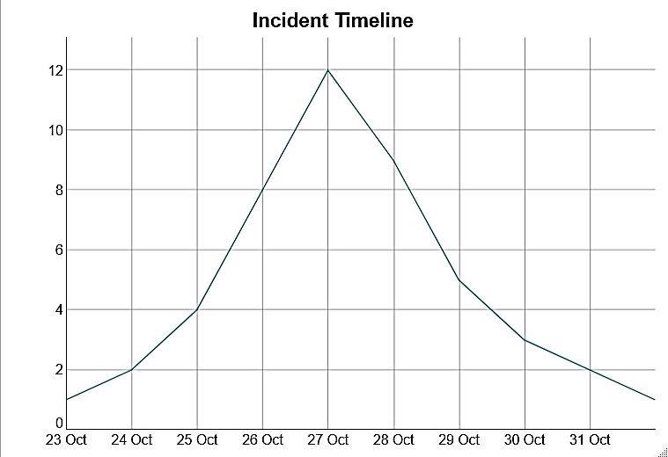
Exp34:
library(DiagrammeR)
library(dygraphs)
library(xts)
x <- xts(cbind(
MTTD = c(20,18,17,15,14,12,11,10,9,8),
MTTR = c(40,38,35,33,30,28,25,22,20,18)
), order.by=as.Date("2026-10-26")+0:9)
dygraph(x, main="MTTD and MTTR")
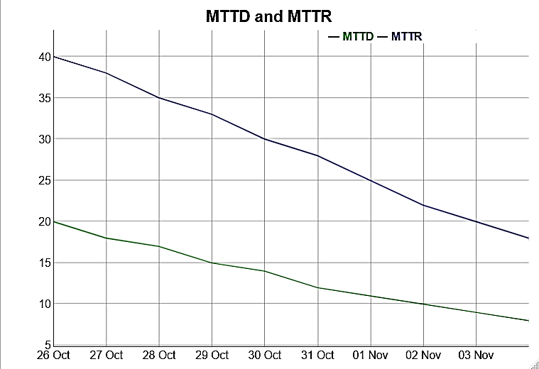
Exp35:
library(DiagrammeR)
library(dygraphs)
library(xts)
x <- xts(cbind(
Compliance = c(70,72,75,77,80,82,84,87,90,92)
), order.by=as.Date("2026-10-28")+0:9)
dygraph(x, main="Security Compliance")
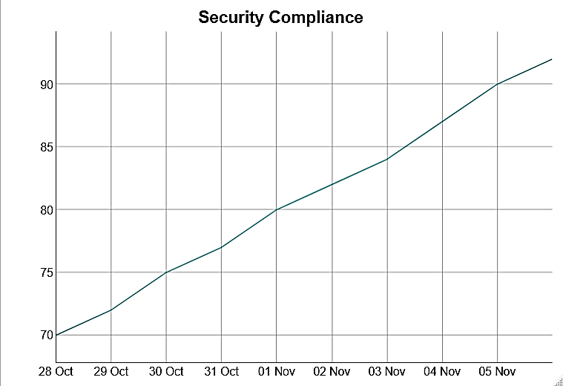
Exp36:
library(DiagrammeR)
library(dygraphs)
library(xts)
x <- xts(cbind(
Risk = c(80,75,70,65,60,55,50,45,40,35)
), order.by=as.Date("2026-10-30")+0:9)
dygraph(x, main="Risk-Based Decision Making")
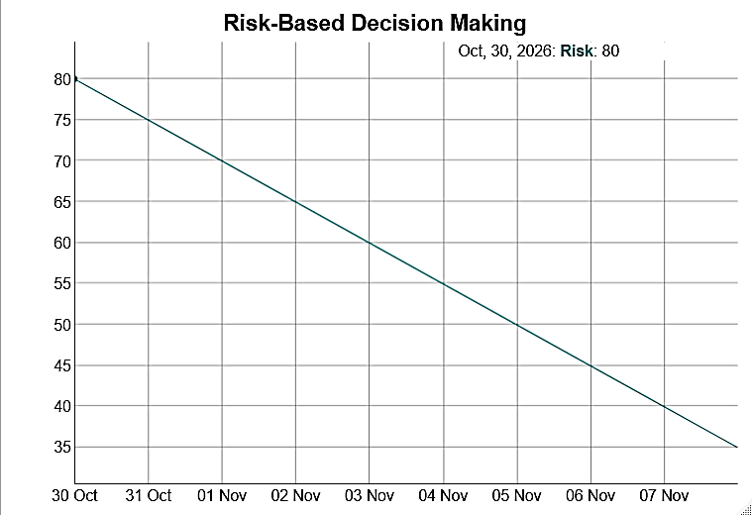
Exp37:
library(DiagrammeR)
library(dygraphs)
library(xts)
set.seed(1)
risk <- rnorm(100, mean=50, sd=10)
x <- xts(
cbind(Risk=sort(risk)),
order.by=as.Date("2026-11-02")+0:99
)
dygraph(x, main="Monte Carlo Risk Simulation")
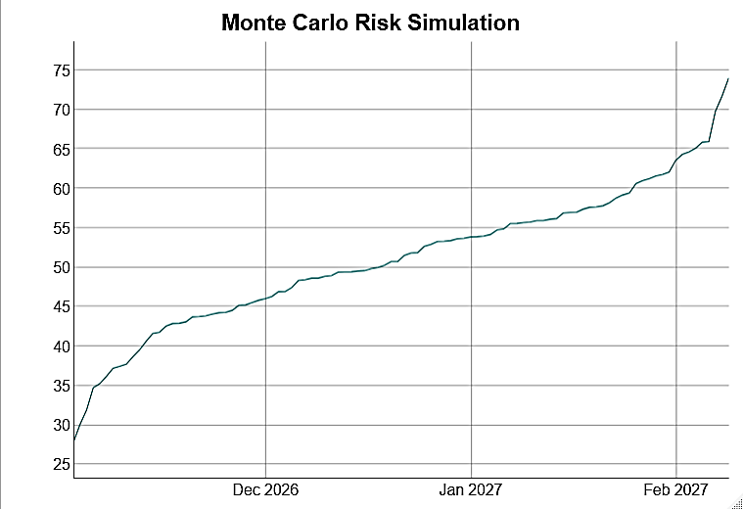
Exp38:
library(DiagrammeR)
library(dygraphs)
library(xts)
x <- xts(cbind(
Secure = c(90,91,92,93,94,95,96,97,98,99),
Insecure = c(70,68,72,65,67,64,62,60,58,55)
), order.by=as.Date("2026-11-04")+0:9)
dygraph(x, main="Secure vs Insecure CI/CD")
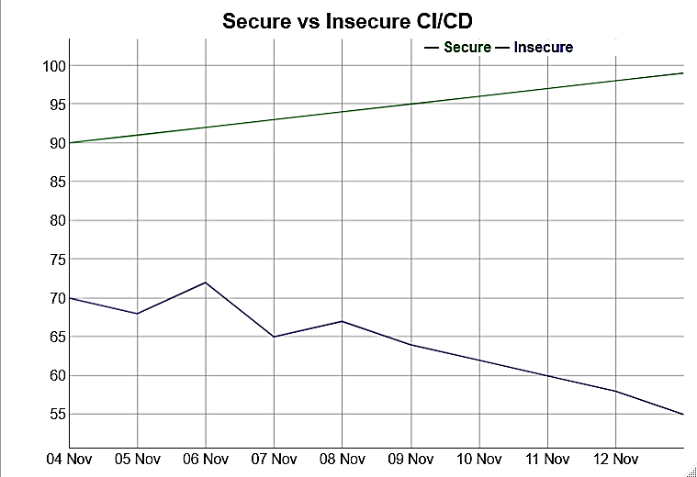
Exp39:
library(DiagrammeR)
library(dygraphs)
library(xts)
x <- xts(cbind(
SecurityScore = c(60,64,68,70,73,76,79,82,85,88),
Vulnerabilities = c(20,18,17,15,13,11,9,7,5,4)
), order.by=as.Date("2026-11-06")+0:9)
dygraph(x, main="Integrated Security Analytics")
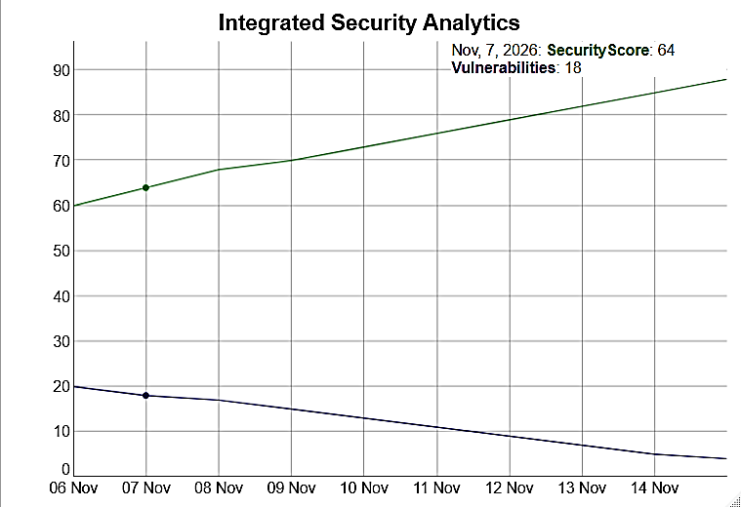
Exp40:
library(DiagrammeR)
library(dygraphs)
library(xts)
x <- xts(cbind(
Build = c(70,72,75,78,80,82,84,86,88,90),
Security = c(60,64,68,72,75,78,81,84,87,90),
Deployment = c(55,60,65,68,72,76,80,84,87,91)
), order.by=as.Date("2026-11-09")+0:9)
dygraph(x, main="End-to-End DevSecOps Pipeline")
